Reveal Your Inner Goddess
Reflective Feedback

Once you have completed this Theme’s material with your private or public Training Circle, let me know how your experience was by completing the following feedback. Please note that this is optional but a great way to ask me specific questions about this Theme. However, to receive Certification this needs to be completed and returned to me in your own time using the following guidelines: 1. Download this form 2. Enter your comments below 3. Email moonmna13@moonmna.ie Thank you.

Name:

Personal Experience
What has been your awareness of the concept of your ‘Inner Goddess’ and the idea of revealing her after looking at the Course Material?

How was the ‘Air’ Scarf Cleanse?

When revealing your Inner Goddess to be photographed how did you feel?

Physically:

Mentally:
Emotionally:
Energetically:

How was your Fire/Water Ceremony? Which one did you use and why?

How did you find using the Chant ‘Who am I, deep inside, reveal, reveal. Goddess I, deep inside, reveal, reveal’? Or did you use something else?

Facilitation Experience
When facilitating this Theme, please describe how it was for you personally?

How did the women in your Circle respond to this Theme?

How was your holding of Sacred Space and safety maintained? Did any issues arise for women and if so, how did you manage this?

Given your experience, preferences and skills, would you do anything different?

General Feedback on the Reveal Your Inner Goddess Theme
Presentation/Content and Delivery:
Any other comments on the Course so far/questions you wish to ask?

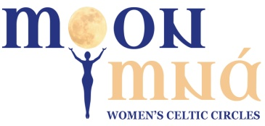 Copyright @moonmna 2009

