Moon Mná Annual Retreat

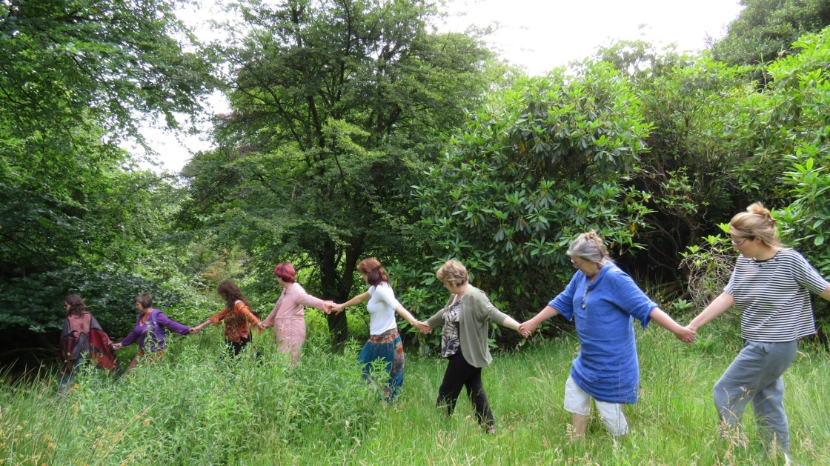

Booking Form

DATE
Friday 8th to Tuesday 12th July 2022

TIME
Friday - Arrive from 5.45pm - Supper 7.00pm - Start Circle 8.00pm,
Tuesday - Finish after Breakfast approximately 10.00am.

VENUE
Mucklagh Lodge, Aghavannah, Co.Wicklow – A beautiful tree surrounded Retreat high in the Wicklow Hills, directions in main email (approx. 1 hour from Dublin) www.mucklaghlodge.com https://mucklaghlodge.wixsite.com/wicklow

BOOKING FORM

Name:

Address:

Email:

Telephone:

Next of Kin - name and contact number:

COST
Inclusive long weekend with high quality vegetarian food and four nights accomodation.

1.Have you paid in full for a Twin Room?

Do you snore?

If so, then please go for the Camping/Campervan option OR share with a friend.
thank you.

Name of the friend you wish to share with.

2.Have you paid in full for a Camping/Campervan pitch?

If so, are you sharing with anyone else?

Name of the friend you wish to share with.

3.Have you paid a Deposit and intend to pay the rest on arrival?

If yes is this for a twin room OR camping or a campervan?

Yes or No here.
.......................................................................................................................................
FOOD
There will be high quality vegetarian, if you have any food allergies or requirements please let us know below. We may not be able to cater for you if you do not complete this on booking. Please enter any requirements below.

.......................................................................................................................................
OTHER DETAILS
Why are you called to this weekend?

Do you have any experience of women’s Circles or Shamanism?

Do you need a lift to Mucklagh Lodge?
Where are you coming from? Can you get to Dublin city/Park & Ride LUAS/DART station, Bray train station or Glenmalure Lodge by bus to be collected?

Can you offer a lift to one or more?
Where are you coming from? Can you pick someone up from Dublin city/Park & Ride LUAS/DART station, Bray train station or Glenmalure Lodge?

Sign/print name: Date:

We look forward to sitting in circle with you, Beannachtaí, Blessings.

