Keening
Reflective Feedback
Once you have studied this Theme’s material and held your private or public Training Circle, let me know how your experience was by completing the following feedback questions. Please note that this is optional but a great way to ask me specific questions on the Theme. However, to receive Certification this must be completed and returned to me in your own time using the following guidelines: 1. Download this form 2. Enter your comments 3. Email it to moonmna13@moonmna.ie. Thank you.

Name:

Personal Experience
What was your overall awareness/impression of the Keening Theme?

How was your Solo Keening Scarf Cleanse? Or did you use something else?

How did you experience the Keening yourself?

Physically:
Mentally:
Emotionally:
Energetically:

How was your Fire/Water Ceremony? Which one did you use and why?

How did you find lilting/humming for your Fire/Water Ceremony?

Facilitation Experience
When you facilitated this Theme, please describe how it was for you personally.

How did the women in your Circle respond to this Theme?

How was your holding of Sacred Space and safety maintained?

Given your experience, preferences and skills, would you do anything different?

General Feedback on this theme
Presentation/Content:
Any other comments on the Course so far/questions you wish to ask me?
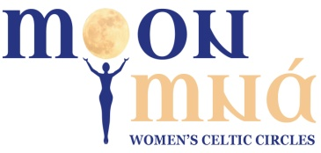 Copyright @moonmna 2009. All rights reserved.

